1. LAN : small house/office(Ethernets /wifi)

(local area network)

1. MAN: Across the city

(Metropolitan area network)

1. WAN: Across countries(optical fiber cables)

i)Sonet -**Synchronous Optical Network ---- it carries the data** the data using optical fiber cables and it can cover larger distances.

ii)Frame relay – it’s a way to connect the local area network to the wider area like internet.

(Wide area network)

1. Tropologies- BUS,RING,STAR,TREE,MESH
2. OSI MODEL—open systems inter connection model

OSI MODEL LAYERS – 1)application layer 2) presentation layer 3)session layer 4) transport layer 5)network layer 6)Data link layer 7)physical layer

**Application layer-** its implemented into software.

**Presentation layer-** its encryptthe data, it also provide abstruction.

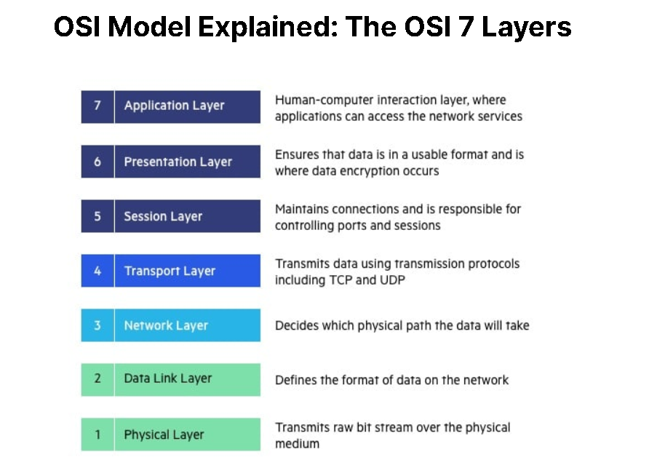

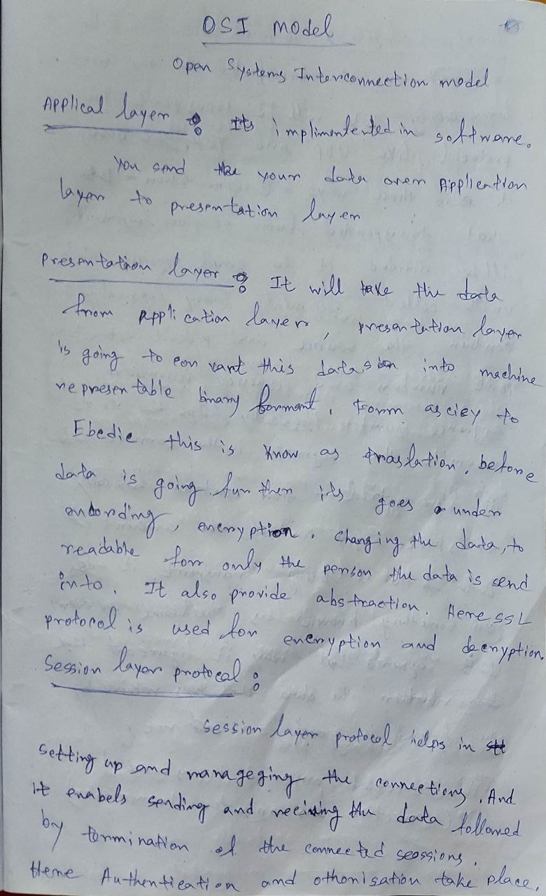

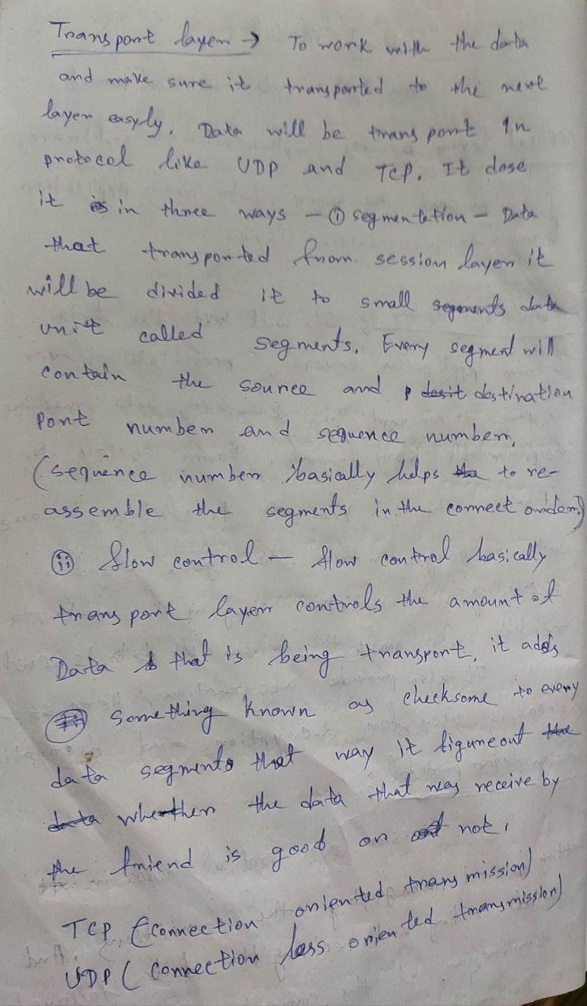

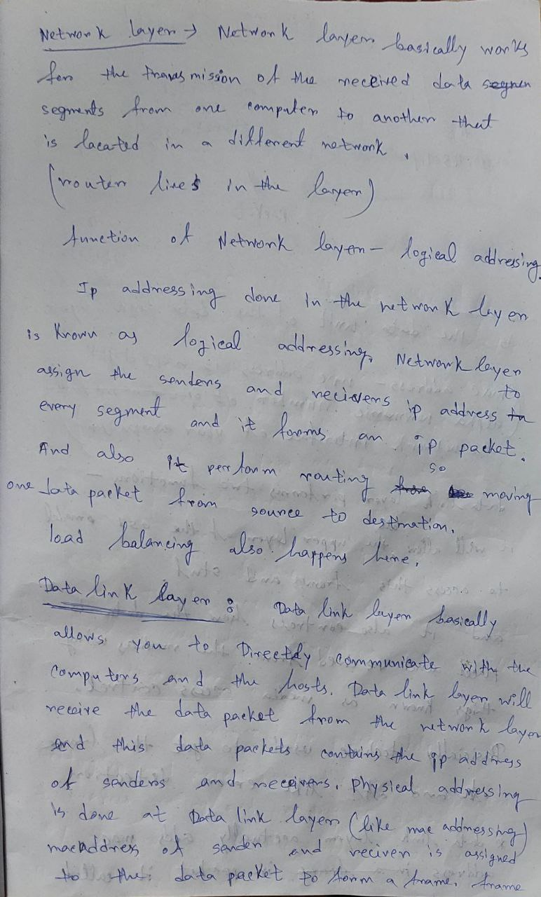

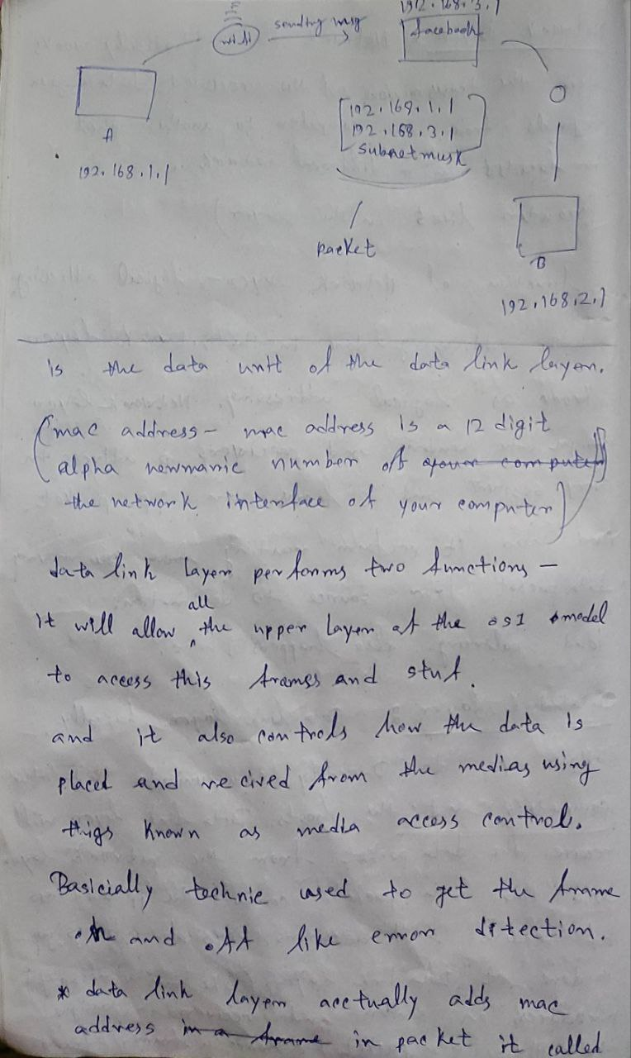

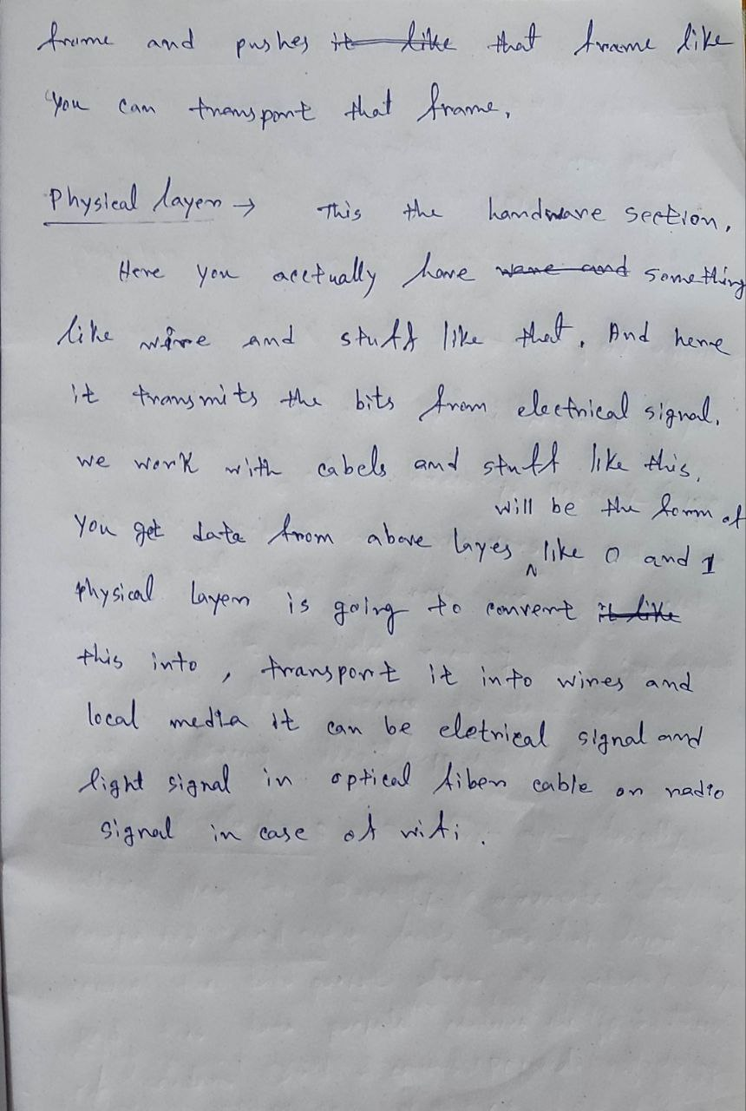

**TCP/IP model**

It’s kind a similar like OSI model but it has only 5 layers

The layers are-

1)application layer 2)Transport Layer 3)Network layer 4)Datalink layer 5)Physical layer

1) Application layer-

Protocols:

Web protocols:

TCP/IP:

HTTP= hyper text transfer protocol : it defines how the data is transferred, html pages and stuff like that

DHCP= Dynamic host control protocol : it basically allocates ip address that people or devices allocated to your network.

FTP= file transfer protocol: how file can be transferred

SMTP= simple mail transfer protocol : it used to send the email.

Pop3 and IMAP = to receive the email we use pop3 & Imac.

SSH= Secure shell : if you want to login to someone else’s computer you need to use SSH

VNC= virtual network control : for graphical control

Telnet = Telnet basically a terminal emulation that enable a user to connect to host or device via telnet client : usually its over port “23”

Command- Telnet Hostname lands you in the hostname

HTTPS = Here “s” means secure. Here we get data which is encoded or encrypted.

UDP= state less connection : data may be lost in this like video call.

Socket = interface between process and the internet.

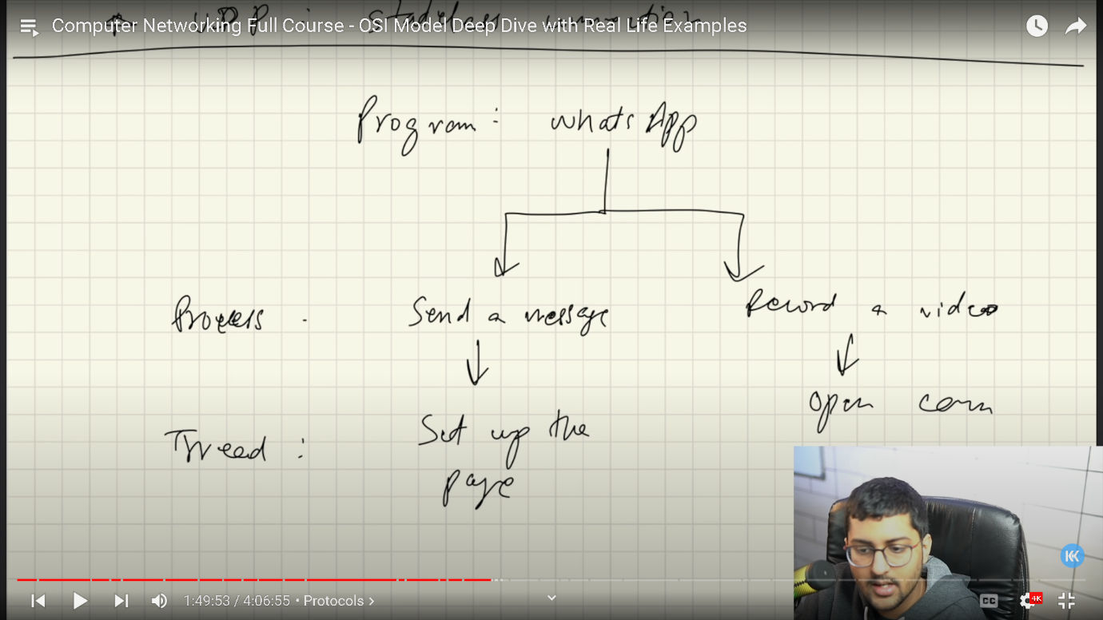

Thread: Thread is a lighter version of a process.

Ports : ephemeral ports.

HTTP= http is a user client protocol. HTTP used tcp(transmission control protocol) : it’s actually a stateless protocol .server will not save any information about the user.

(“HTTP is a application layer protocol and TCP actually is Transport layer protocol.”)

HTTP METHODS = 1)GET 2)POST 3)PUT 4)DELETE

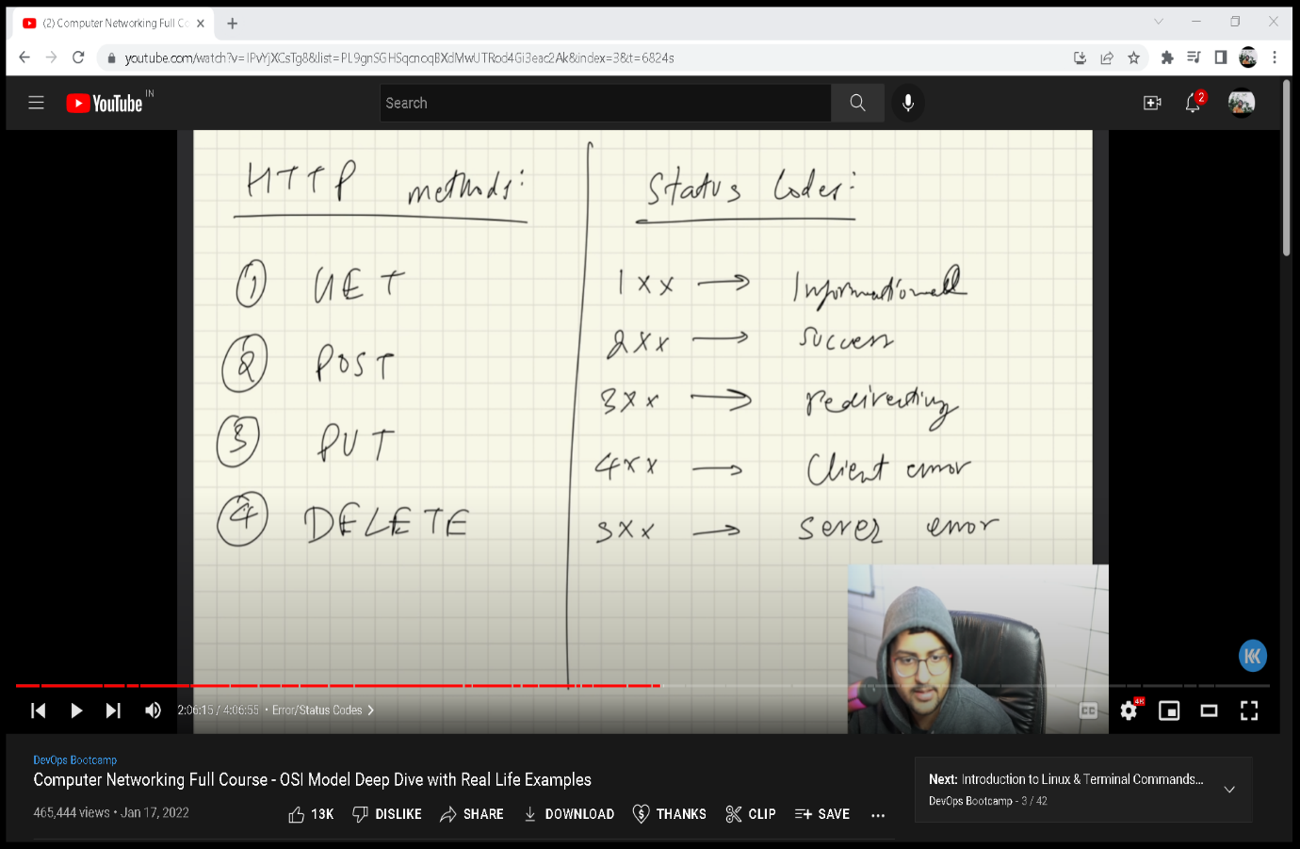

COOKIES = unique string

Stored in users browser. And cookies are send as a header of request.

Third party cookies = A third-party cookie is placed on a website by someone other than the owner (a third party) and collects user data for the third party.

Email works : in this protocols like SMTP(simple mail transfer protocol) , pop3 (post office protocol) and imap(it allows you to see your emails on multiple servers).

*DNS = Domain name system.

Basically domain names are mapped to ip address.

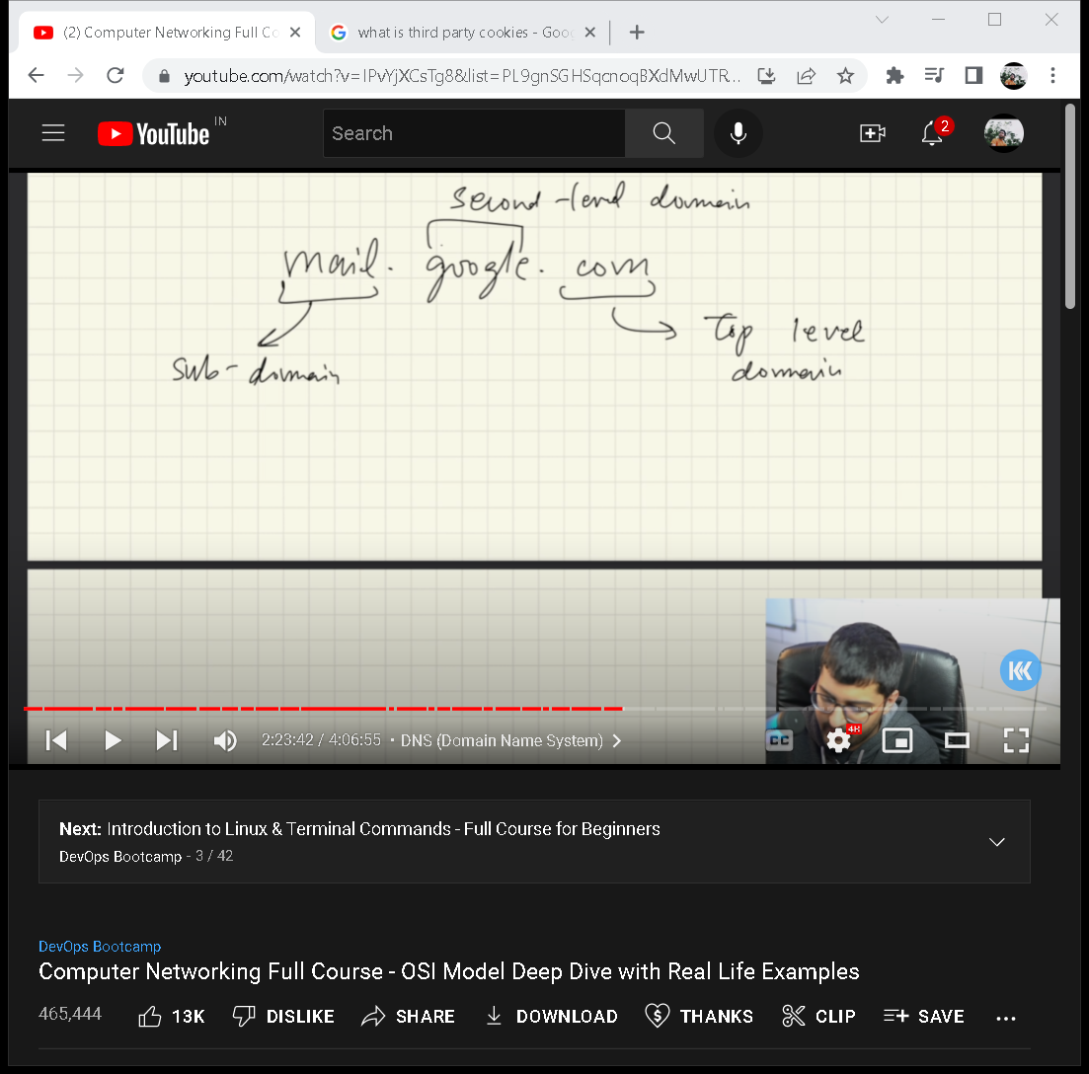

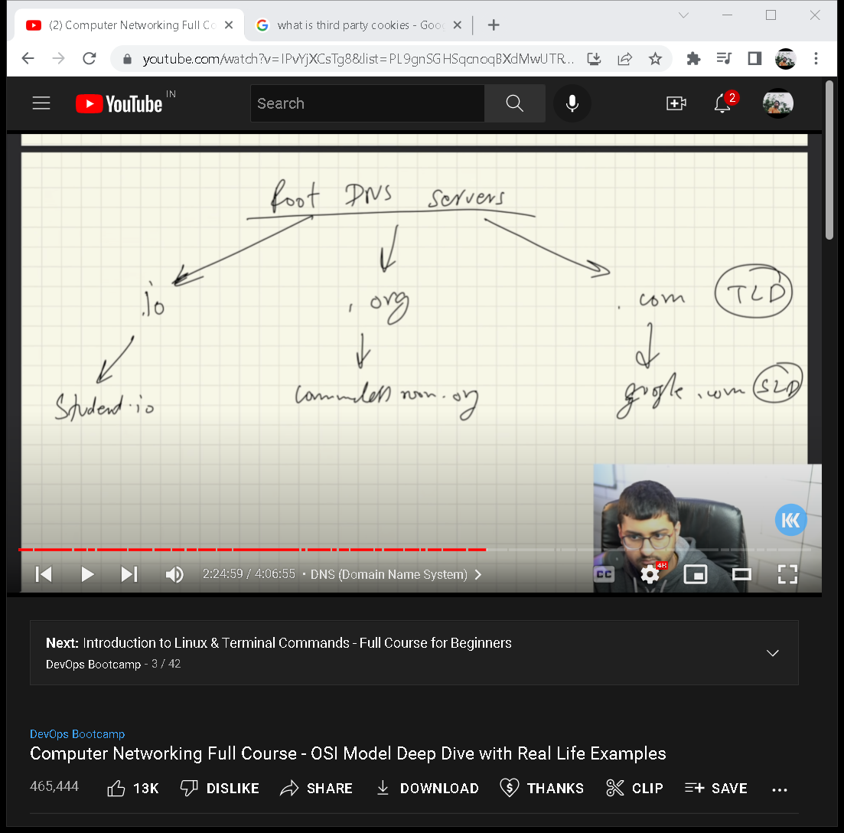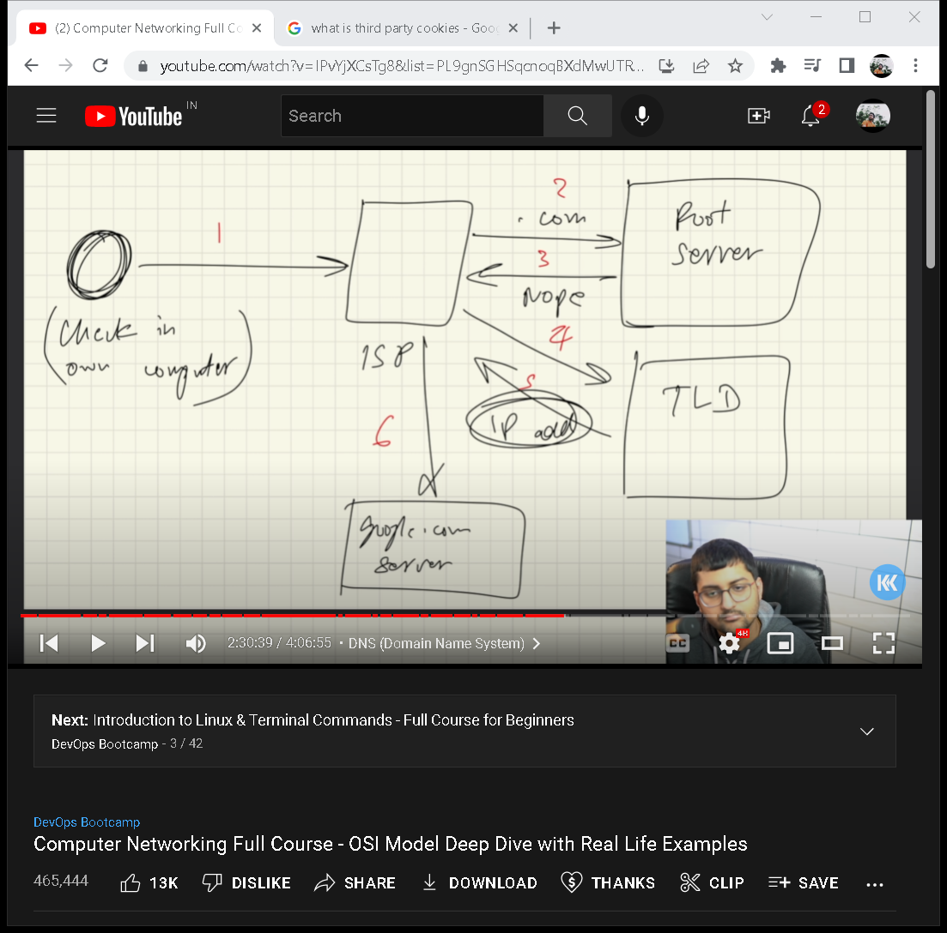

**2) Transport Layer:**

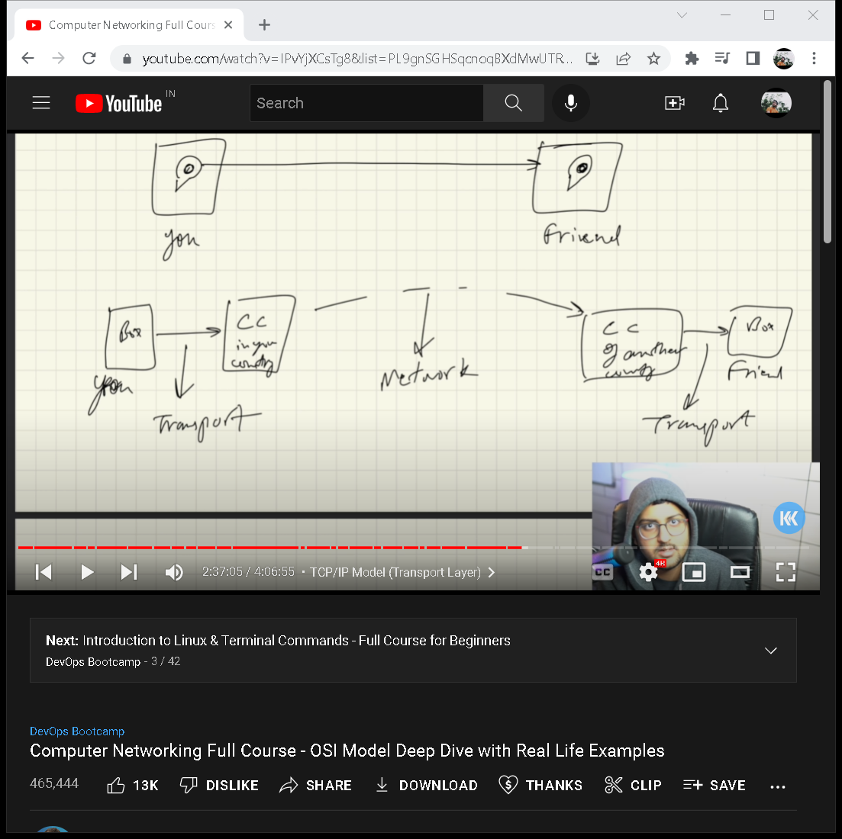

Transport layer multiplexer and de multiplexer :

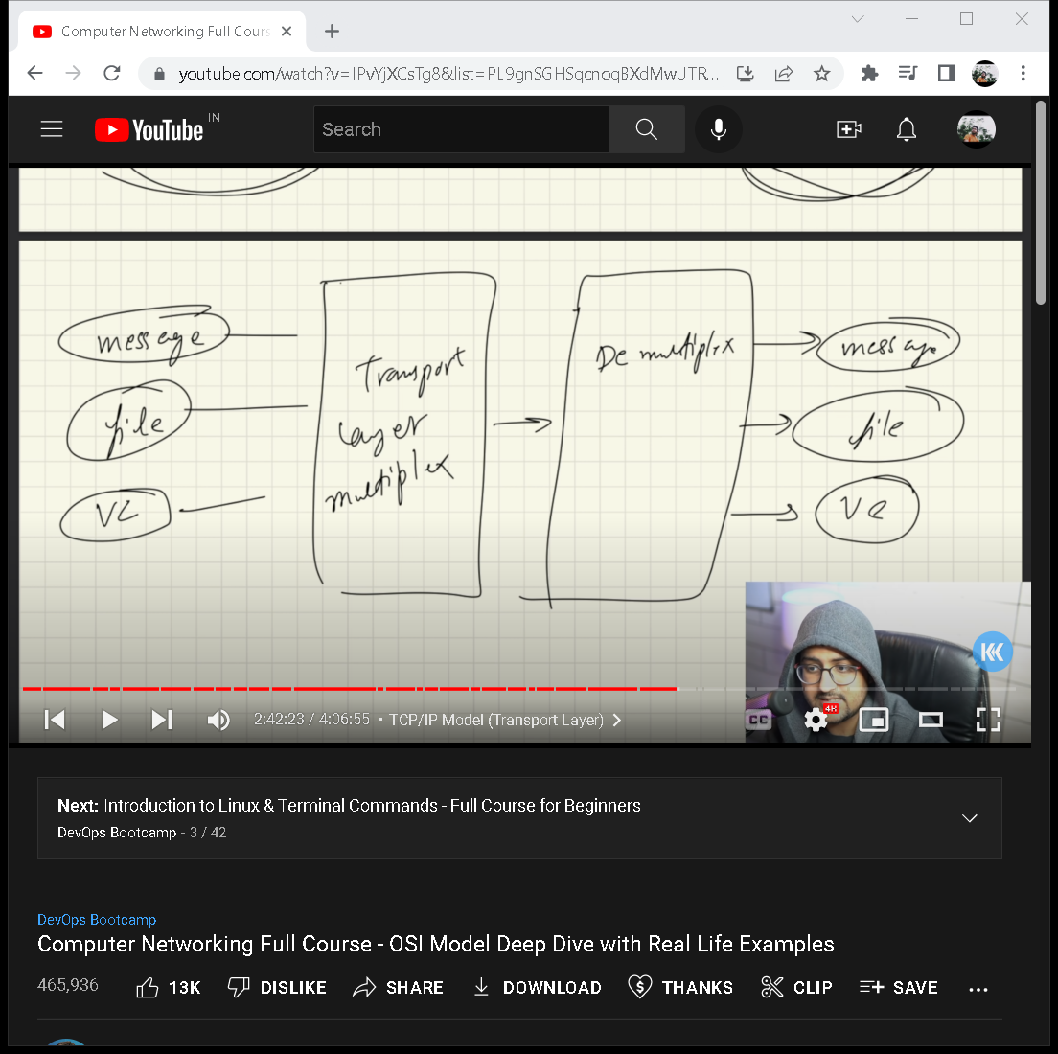

Socket = A socket is one endpoint of a two-way communication link between two programs running on the network. A socket is bound to a port number so that the TCP layer can identify the application that data is destined to be sent to. An endpoint is a combination of an IP address and a port number.

*Data travels in packets, this transport layer will attach socket ports with it.

*Transport layer also takes care of congestion(/traffic) control.

( congestion control= a mechanism that controls the entry of data packets into the network, enabling a better use of a shared network infrastructure and avoiding congestive collapse.)

*congestion control algorithms built in tcp.

*checksum = value that represents the number of bits in a transmission message and is used by IT professionals to detect high-level errors within data transmissions.

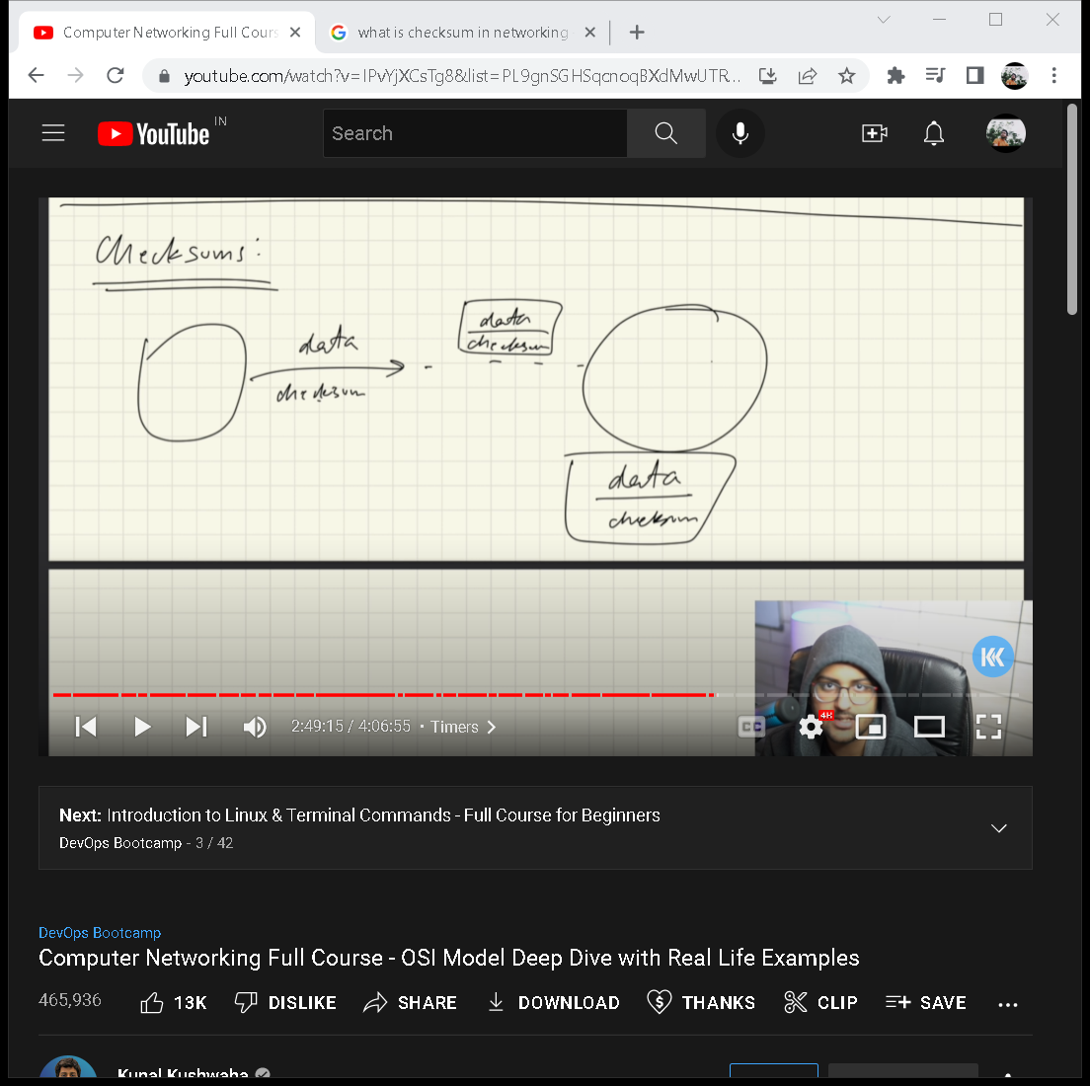

Timers :

Retransmission Timer – To retransmit lost segments, TCP uses retransmission timeout (RTO). When TCP sends a segment the timer starts and stops when the acknowledgment is received.

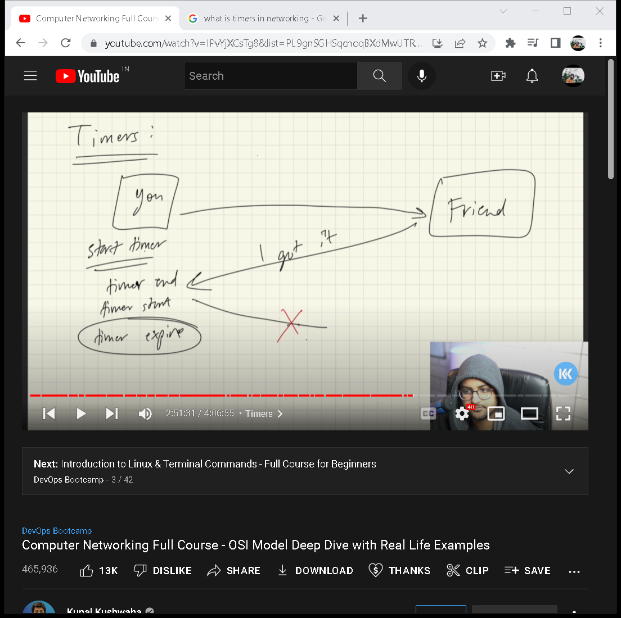

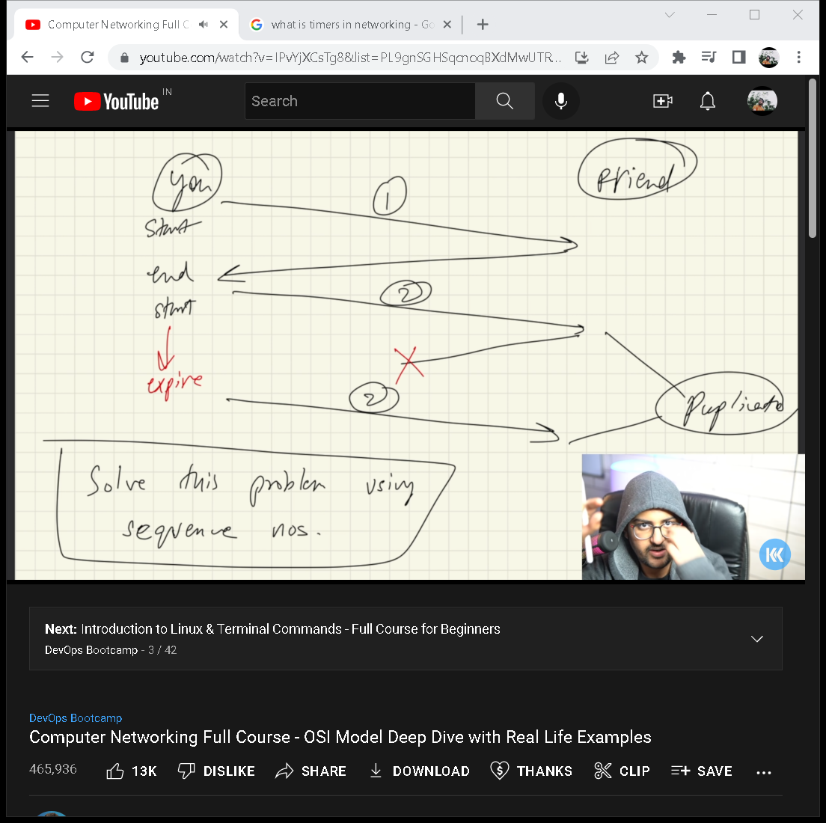

(sequence numbers)

**UDP(user datagram protocol) =**

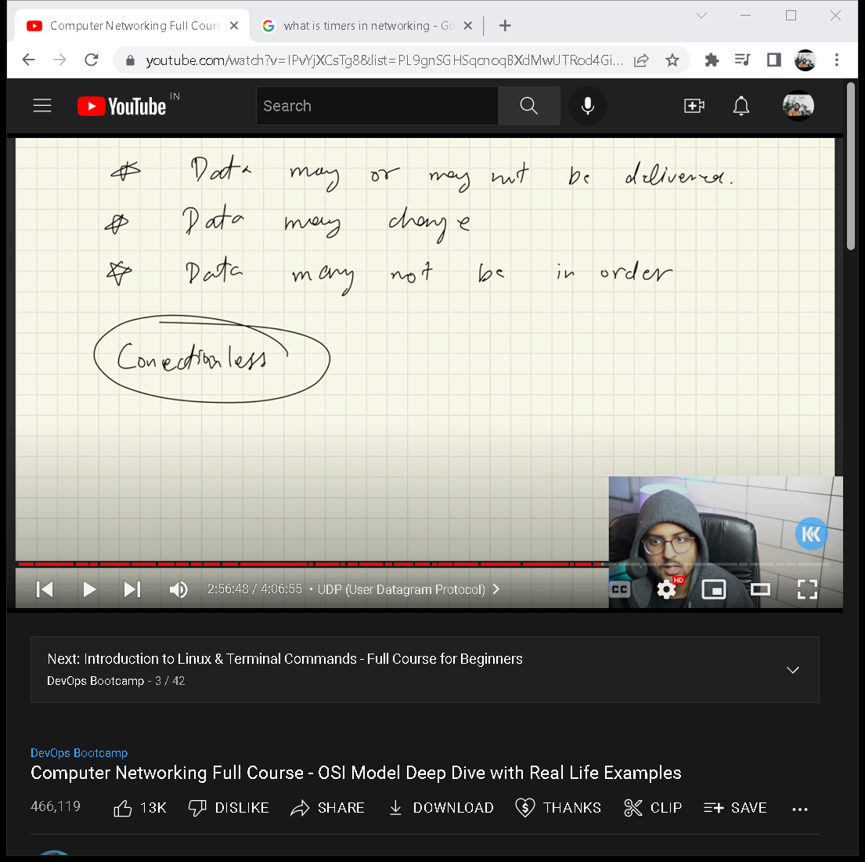

UDP uses chechssum.

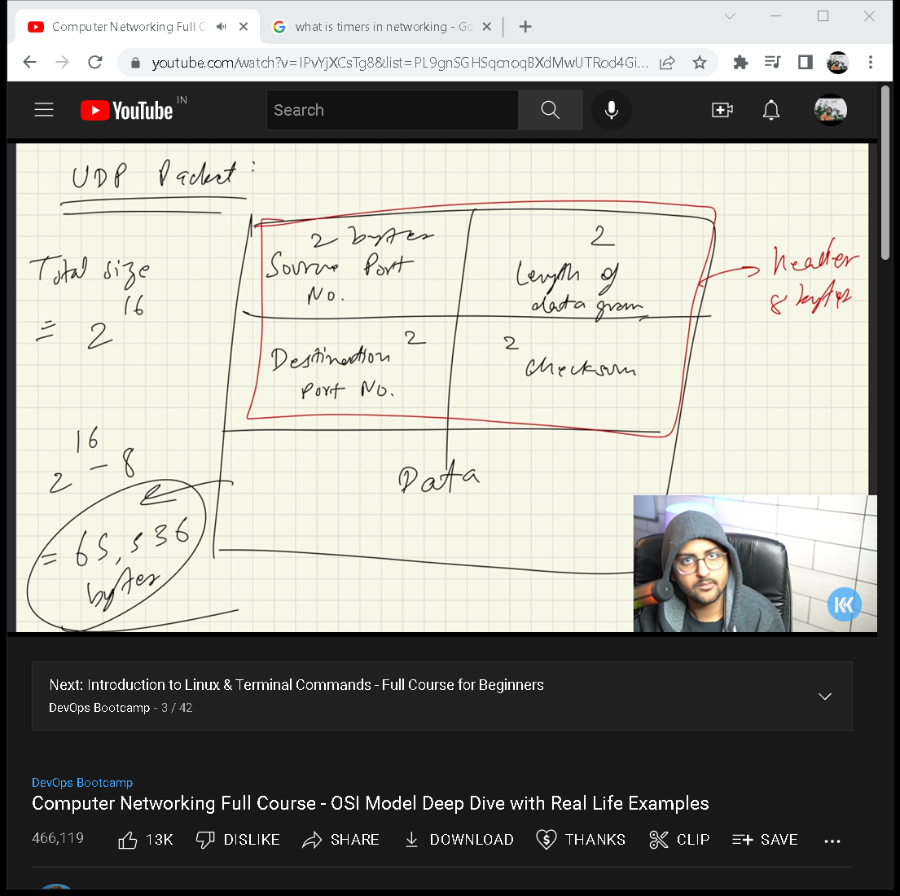

Uses cases of udp=

It’s very fast

Video cong apps

DNS 🡪 udp

Gaming

**TCP (transmission control protocol) =**

1. Its in Transport layer protocol.
2. Application layer sends lots of raw data, tcp segments this data -> divide into chunks add headers, checksum etc. it may also called the data network layer(basically it put together data, which is came from network layer in more smaller chunks)
3. Congestion control.
4. It takes care of --- when data does not arrive

--- maintain the order of data(using the sequence number)

**Features =**

1)it’s connection oriented(first connection get established then file get transferred)

2) its also provide Error control

3) congestion control

4)full Duplex ( both computers can send simultaneously)

5)it will add sequence number and acknowledgement number and checksum and stuff.

**3-way handshake:**

**Step 1 (SYN):** In the first step, the client wants to establish a connection with a server, so it sends a segment with SYN(Synchronize Sequence Number) which informs the server that the client is likely to start communication and with what sequence number it starts segments with

**Step 2 (SYN + ACK):** Server responds to the client request with SYN-ACK signal bits set. Acknowledgement(ACK) signifies the response of the segment it received and SYN signifies with what sequence number it is likely to start the segments with

**Step 3 (ACK):** In the final part client acknowledges the response of the server and they both establish a reliable connection with which they will start the actual data transfer.

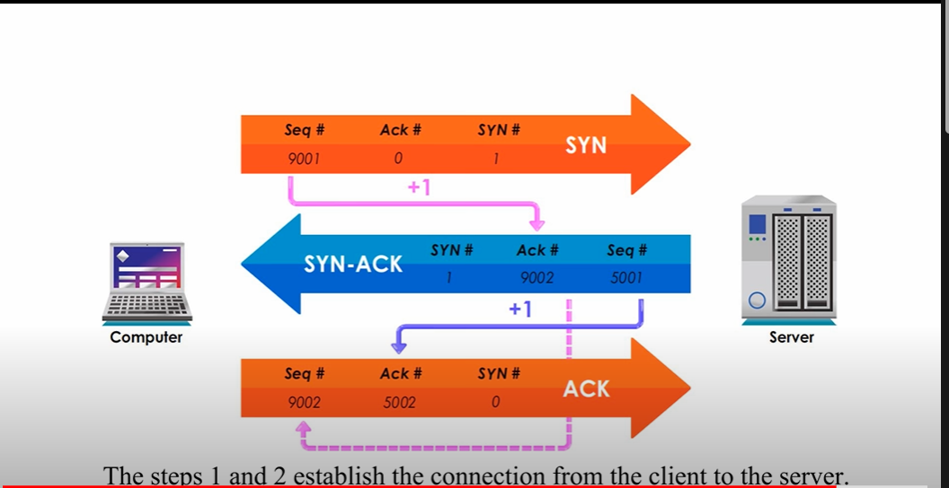





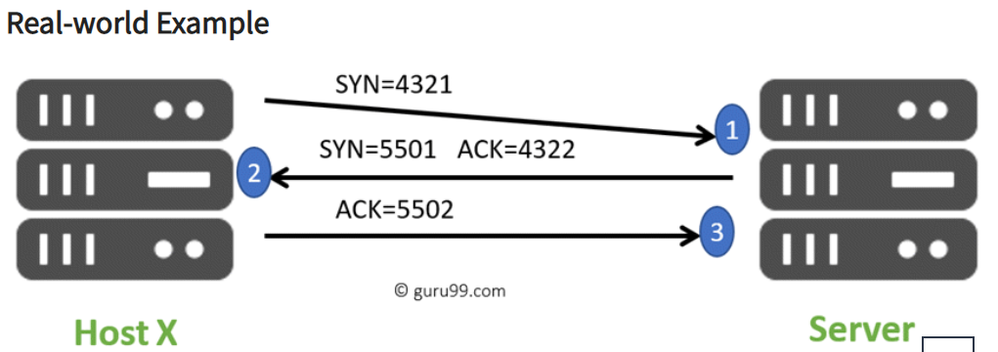

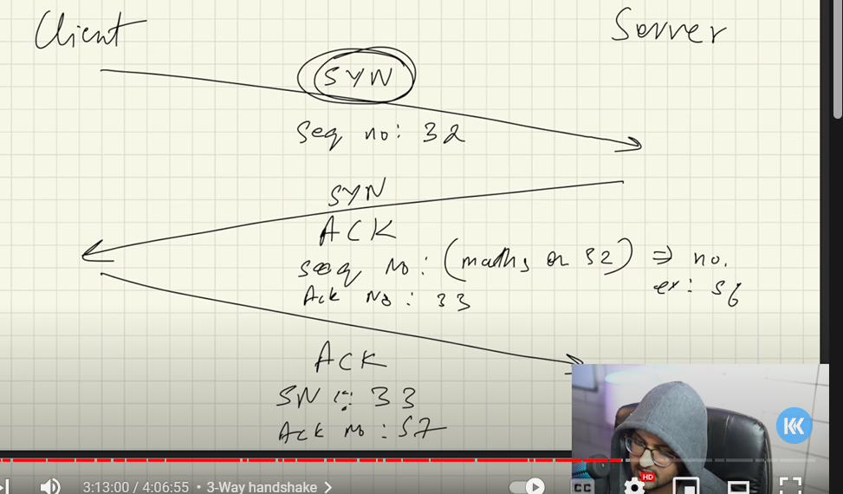

**Network layer**

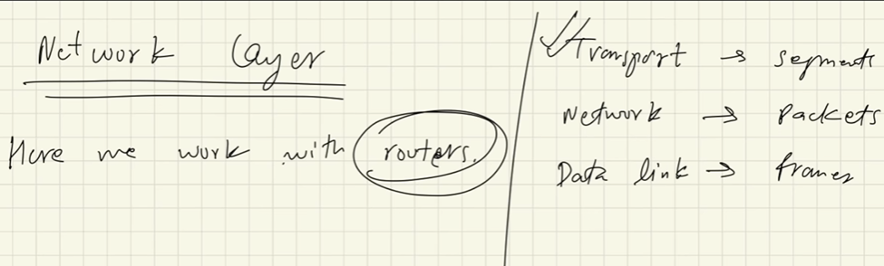

Packet = contains network layer address of destination , network layer address of the person who is sending it and what information you wanted to send.

*routing table –

*forwarding table

IP address =

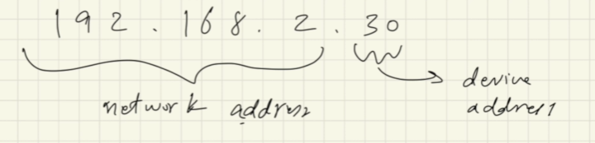

Control plane =

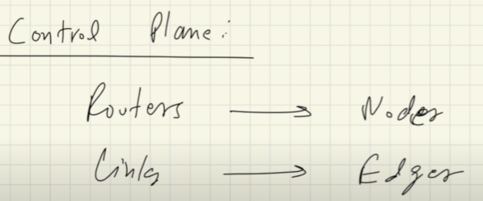

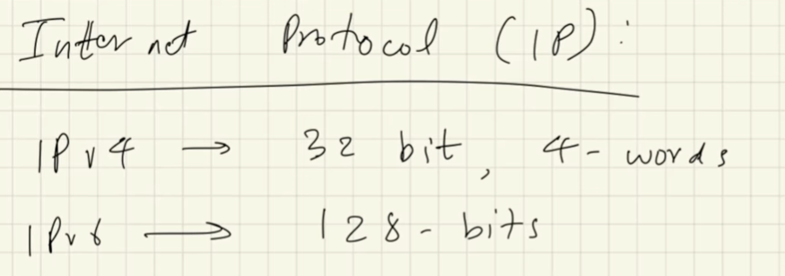

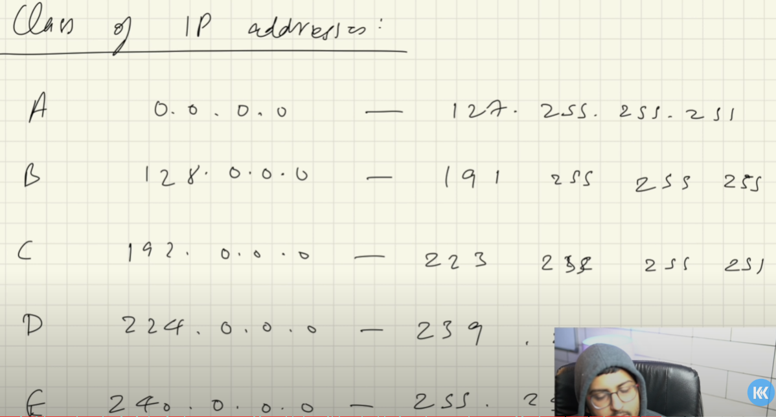

D=239.255.255.255

E=255.255.255.255

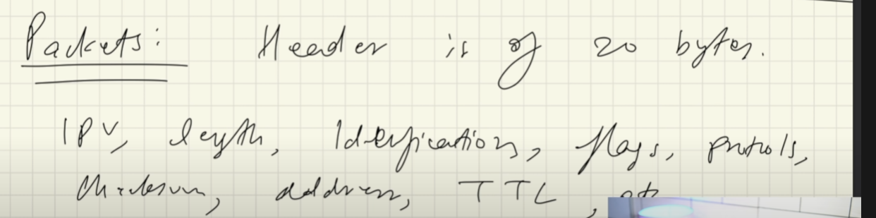

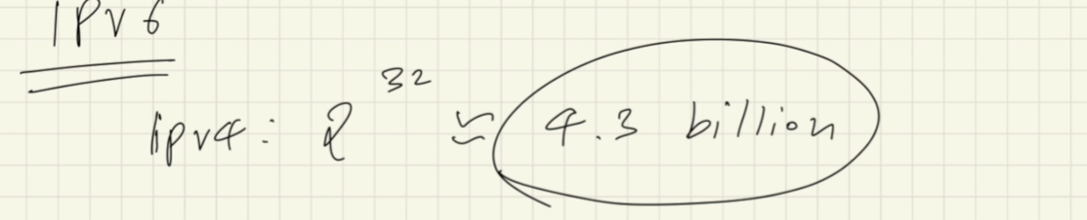

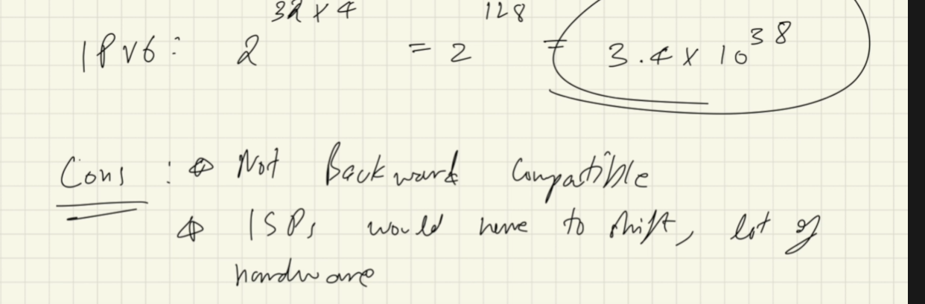

*lots of hard work

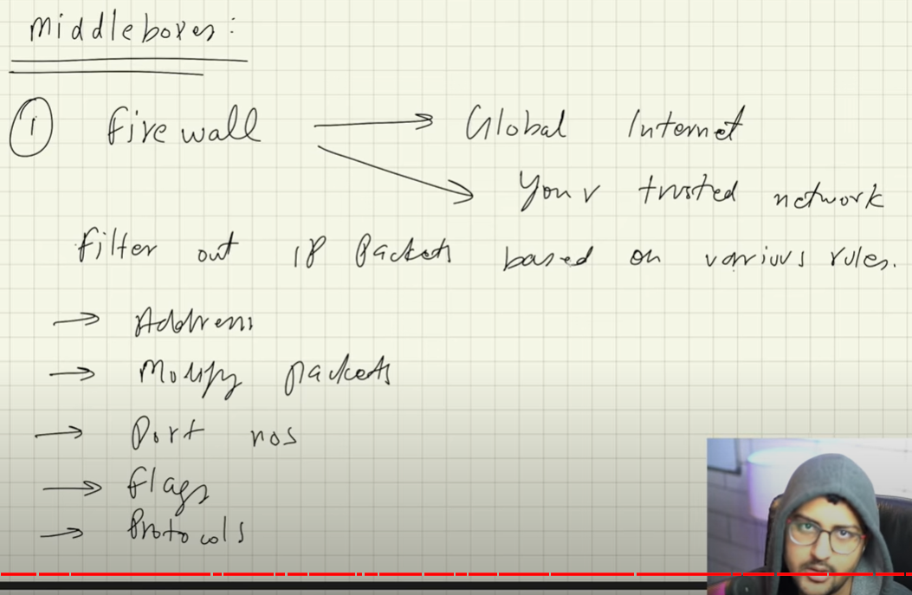

NAT=

NAT stands for network address translation. It's a way to map multiple local private addresses to a public one before transferring the information. Organizations that want multiple devices to employ a single IP address use NAT, as do most home routers.

**DATA link layer:**

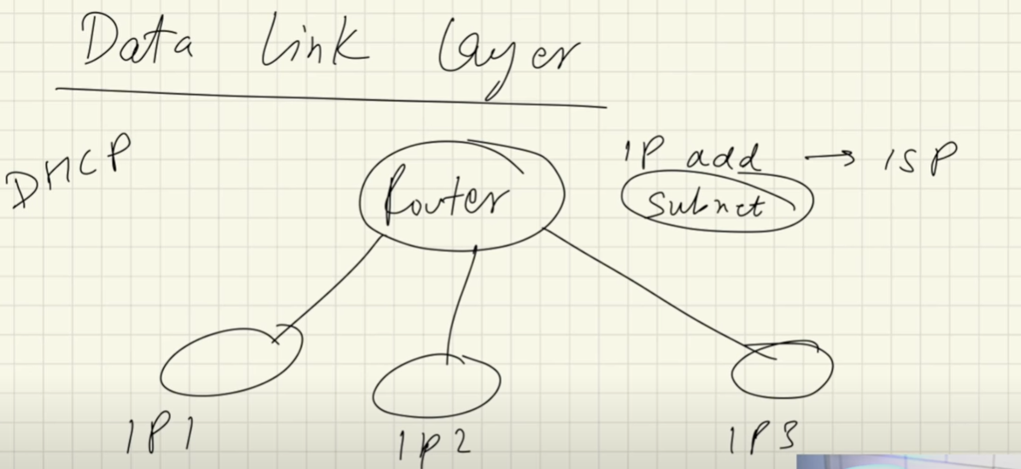

(Subnet=)

